**LAB REPORT - BASH SCRIPTING**

Course Code - Course Name: - COMP4041 - Operating System

Program: T433 - Cybersecurity

Term: - Winter 2024

Lab Number - Topic: Lab 4 – BASH SCRIPTING

Student Name - ID: Prabhjot Singh Sains – 101495218

There are many more things we can do with Bash scripting, and it's a great way to automate tasks and save time. The objective of this lab exercise, we'll be going over the basic syntax and features of scripting to enable you all to build tools to make your workflows easier! We will create a Bash script that takes input from the user and performs some simple operations on it.

**Exercise 1: File System Operations**

* Task 1 involves writing a script that prompts the user to input a name for a new directory and then creates a directory with the provided name.

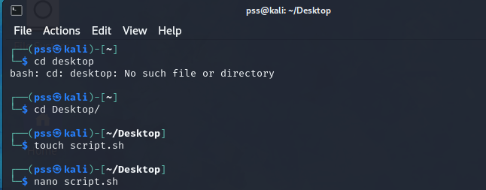

Fig 1. Creating a script file and opening it in the text editor

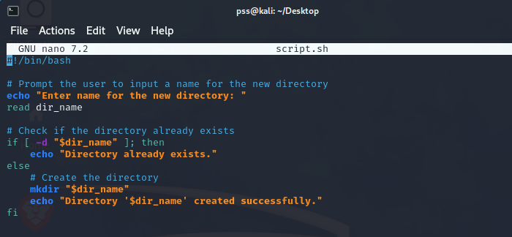

Fig 2. Writing Script in the script file using a text editor

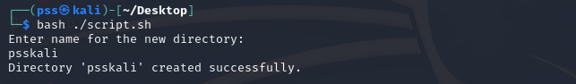

Fig 3. Running the script with the Bash command and the Output

* Task 2 Create a script that lists all files in a given directory (and its subdirectories) that have a specific extension (e.g. .txt).

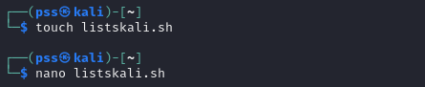

Fig 4. Creating a script file and opening it in the text editor

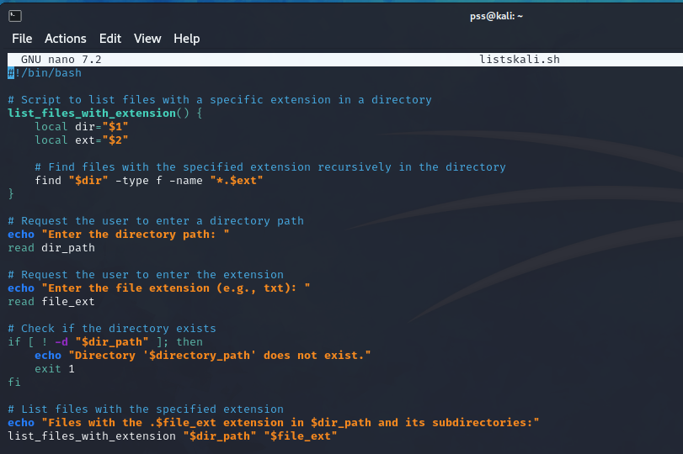

Fig 5. Writing Script in the script file using a text editor

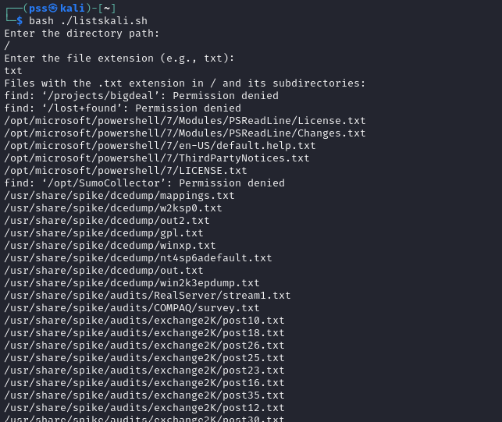

Fig 6. Running the script with the Bash command and the Output

**Exercise 2: Text Processing**

* Task 1 Write a script that requests the user to enter a filename and then count the number of lines, words, characters, white spaces, the lines containing a number, and special symbols.

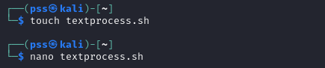

Fig 7. Creating a script file and opening it in the text editor

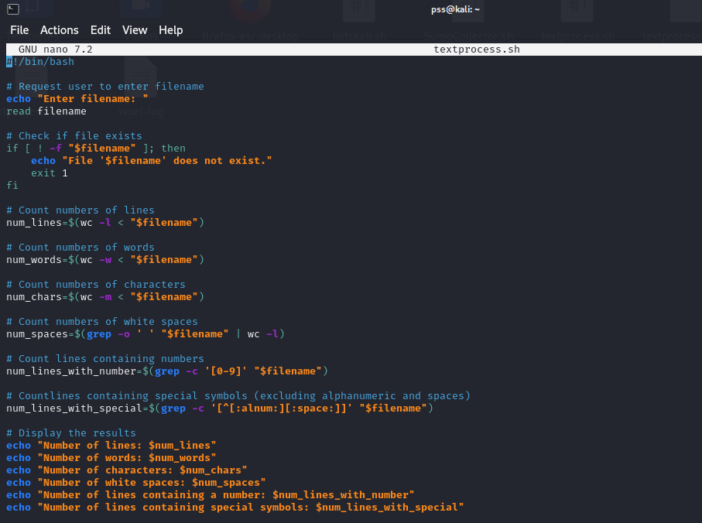

Fig 8. Writing Script in the script file using a text editor



Fig 9. Creating a text file and opening it in the text editor

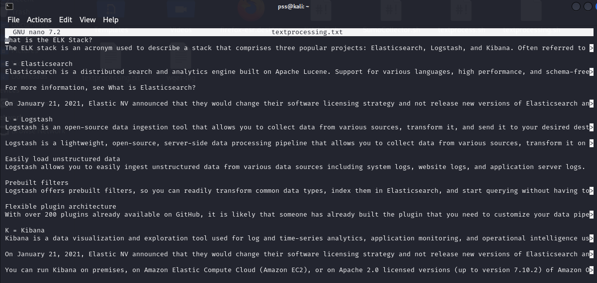

Fig 10. Adding text in the file using a text editor

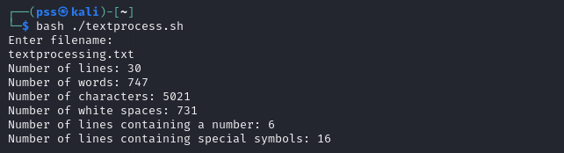

Fig 11. Running the script with the Bash command and the Output

**Exercise 3: Challenging scripting**

* Task 1 Write a script called countdown that prints output similar to the following:

10

9

8

7

6

5

4

3

2

1

GO!

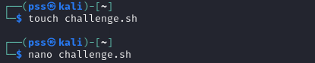

Fig 12. Creating a script file and opening it in the text editor

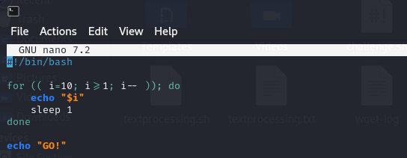

Fig 13. Writing Script in the script file using a text editor

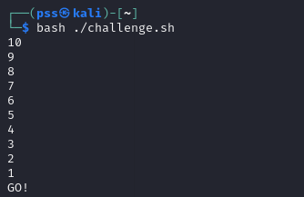

Fig 14. Running the script with the Bash command and the Output

* Task 2 Write a script called largest that finds the largest among the 3 given numbers.

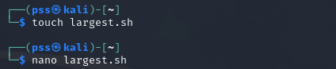

Fig 15. Creating a script file and opening it in the text editor

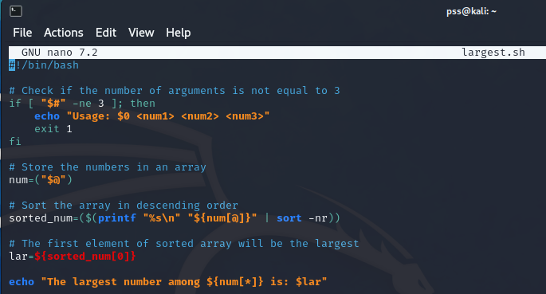

Fig 16. Writing Script in the script file using a text editor

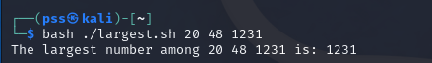

Fig 17. Running the script with the Bash command and the Output